4 Tips on Relocating to a New Neighborhood
Relocating to a new neighborhood can be a daunting task. There can be so many unknowns.
Here are a few tips to make your neighborhood transition easier.
1. Find a real estate agent who has experience in the area you wish to move to. Ask your local agent for a referral. You are usually best served by working with an agent recommendation.
2. Doing your own research will complement your agent’s efforts to find the area that best suits you. Take some time to personally check out the amenities, resources and schools in the neighborhoods that you are attracted to. Drive through different areas and take note of pride of ownership, activity level and how safe you would feel living in certain neighborhoods.
3. Consider renting before you buy. Renting is a good way to find out if a certain neighborhood is right for you without making the big investment of buying first. If you can rent for a year, you should gain intimate knowledge of the area and what it has to offer. You will learn how property values are trending.
4. If you want the best of both worlds, have your agent locate a rent-to-own opportunity in the neighborhood you are targeting. A portion of your monthly rent goes to your down payment should you decide to exercise your purchase option. This is a good way to test the area without full commitment to owning.
Please contact me to discuss more ways to make your next move a successful one.

The Hiking Grandma Who Inspired Generations to Get Outside
Emma Rowena Gatewood was the epitome of achieving greatness regardless of age or background. Better known as "Grandma Gatewood," she was born into poverty in Ohio in 1887 but gained fame as the first woman to hike the entire Appalachian Trail solo. Not only that: her first completion of the trail incredibly came in 1955 when she was 67 years old without any prior hiking experience. She carried a homemade backpack, wore sneakers and relied on her resourcefulness to survive the grueling 2,168-mile journey.
Despite encountering numerous challenges, including bad weather, difficult terrain and hostile wildlife, Gatewood persevered and completed the hike in just over five months. Following her achievement, she was seen as a trailblazer for women's hiking and inspired countless others to pursue their dreams of outdoor adventure. She continued to hike well into her 70s and 80s, completing several other long-distance hikes, including the Oregon Trail and the Long Trail in Vermont as well as further hikes of the Appalachian in 1960 and 1963, breaking another record as the first person to tackle the trail three times.
Gatewood's legacy lives on today, and her story has been the subject of numerous books and documentaries. Her determination, courage and resilience continue to inspire people of all ages and backgrounds to pursue their passions and embrace the challenges that come with them. Her motto, "Make a trail for others to follow," is a testament to her selflessness and the impact she had on the world around her.

June 2023

Buying a home is a complex process with many factors to consider.
Prepare for the decisions you’ll need to make along the way by requesting my free report, “10 Easy Steps to Buying a Home.”

Reach out to 203-555-8987 and I’ll send it right out to you.




Thinking of Buying a Home? Get My Free Guide

2

Brought to you free by Sheila Yaccino
203-555-8987
sheila@sheilayaccino.com

With summer gracing us with its presence once again, a picnic is a great way to enjoy the outdoors with friends and family. However, planning a successful picnic requires some preparation and attention to detail. Here are some tips for a good picnic.
Choose a good location. Choose a location that is scenic, comfortable and has enough space for your group. Look for a place that has shade and shelter from the sun, and consider the amenities available, such as restrooms, tables and grilling areas.
Plan your menu. Plan a menu that is easy to transport, prepare and serve. Pack a variety of foods, such as sandwiches, fruits, vegetables, cheese and crackers. Don’t forget to bring plenty of water and drinks to stay hydrated.
Pack smart. Pack everything you need in a sturdy cooler or picnic basket. Make sure to pack plates, utensils, napkins and cups. Bring a blanket or chairs to sit on, and don't forget sunscreen and insect repellent.
Keep it simple. Keep your picnic simple and relaxed. Don't overcomplicate things with complicated recipes or a long packing list. Remember, the focus of a picnic is spending time with friends and family and enjoying the great outdoors.
Clean up after yourself. Take care of the environment by cleaning up after yourself. Bring garbage bags and pack up everything you brought with you. Leave the picnic area better than you found it.
Be prepared for the unexpected. Weather can be unpredictable, so be prepared for rain or other unexpected events. Bring a raincoat or umbrella, and be ready to move your picnic indoors if necessary.
By following these tips, you can plan a successful and enjoyable picnic that everyone will love. With a little preparation and attention to detail, you can create wonderful memories in the great outdoors with your loved ones.

6 Steps to Creating the Perfect Summer Picnic

Thank you for your referrals!
I succeed when people like you refer me to your friends, neighbors and loved ones. It's the best kind of feedback I can receive.
So thanks for continuing to pass this newsletter on to people you care about.



How Many Homes Should I View?
There is no set rule on how many homes you need to view before making a purchase decision. Statistics indicate that the average home buyer ends up looking at eight homes. Depending on your timeline and search criteria, you could be looking at fewer or more before you make an offer. Market availability will also determine how many homes you end up viewing. When the inventory is low, you will likely have to narrow your criteria and settle for viewing fewer homes. On the flip side, the luxury of too many choices may serve to be a burden and overwhelm you.
Buying the first house you see doesn’t give you the opportunity to compare different properties or make informed decisions based upon your priorities. What matters the most isn’t the number of homes you see but how decisive you feel that a certain home is the one that you are confident in making a strong offer for.
Ultimately, you don’t want to view too few or too many homes. It’s all about balance with your needs and wants.

Ginger-Peach Soda
A splash of rum can be added to this sweet, thirst-quenching drink for an after-dark twist.
Serves 8
1 cup sugar
2 tablespoons minced fresh ginger
2 peaches, halved, pitted and thinly sliced
2 liters seltzer, chilled
Small bunch fresh mint
Ice
In medium saucepan over medium-low heat, bring 1 cup water, sugar and ginger to gentle simmer, stirring to dissolve sugar. Remove simple syrup from heat, cover and steep for about 30 minutes.
Over bowl, pour syrup through fine-mesh sieve, pressing minced ginger against sieve with back of a spoon to extract flavor. Discard ginger. Cover bowl with plastic wrap and refrigerate until well chilled.
Evenly distribute peach slices among eight tall glasses. For each glass, lightly press peaches with back of a wooden spoon to release juice. Pour 2 tablespoons chilled syrup over peaches.
Add ice cubes, then top with seltzer. Stir to distribute syrup, peach juice and seltzer evenly. Garnish with 2 mint leaves. Serve.



This newsletter and any information contained herein are intended for general informational purposes only and should not be construed as legal, financial or medical advice. The publisher takes great efforts to ensure the accuracy of information contained in this newsletter. However, we will not be responsible at any time for any errors or omissions or any damages, howsoever caused, that result from its use. Seek competent professional advice and/or legal counsel with respect to any matter discussed or published in this newsletter. This newsletter is not intended to solicit properties currently for sale.

Summer is a season of sunshine, blue skies and warm weather. It’s also the time when your home will need some adjustments to keep you comfortable and protect your property from the elements. Here are eight tips to help you prepare your home for summer weather.
Give the place a good clean. Across the winter hibernation period, you’ve likely accumulated clutter and missed the dirty spots that are less obvious in the low winter light. Now’s the perfect time to give it a summer sparkle.
Check and clean your air conditioning unit. Before the hot weather arrives, check your air conditioning unit to ensure it’s working properly. Clean or replace filters to improve air quality and efficiency.
Seal cracks and gaps. Check the exterior of your home for any cracks or gaps that may have developed during the winter. Seal them to keep cool air inside and prevent pests from getting in.
Install window treatments. Blinds, shades or curtains help to keep the sun out during the hottest parts of the day. This will keep your home cool and reduce your energy bills.
Prepare your outdoor spaces. Clean and organize your outdoor spaces, such as decks, patios and grilling areas. Consider adding umbrellas or canopies to shade and protect yourself from the sun while enjoying your outdoor spaces.
Service your outdoor equipment. Before using your outdoor equipment, such as lawn mowers and grills, service them to ensure they’re in good working order.
Protect against pests. Summer is a prime time for pests such as mosquitoes, ants and termites. Take steps to protect your home by removing standing water, sealing cracks and gaps, and using pest control products as needed.
By following these tips, you can ensure that your home is ready for the summer weather, keeping you and your family cool, comfortable and safe.
For more tips on preparing your home for summer, call or email me today and we’ll discuss your options.

Keep Your Home Comfortable This Summer with These Tips

Quick Quiz
For an answer, email me at sheila@sheilayaccino.com or call 203-555-8987.
What was the first film shown at the first drive-in in June 1933?

How Our Family Stumbled into Whimsy
Small Adventures
Modern life's pace can cause meaningful moments to slip away, so Sanders Summer Camp is one family's way of slowing down to make special moments last. Each summer has a themed goal, leading to unique experiences like fights with Nerf guns and letting their children drive, or recreating their favorite past activities week by week. See how the Sanders slow down to find more meaningful and lasting joy. More: https://tinyurl.com/worth0623a

Bees Teach Their Babies How to Dance
Dino Grandoni
Washington Post
Honey bees perform a tail-wagging dance to communicate the location of nearby nectar and pollen, and a study has shown that young bees learn this dance by observing older bees. Recent experiments suggest that insects can imitate one another, a behavior known as "social learning" previously associated with bigger-brained animals. Read all about it in this fascinating piece in the Washington Post. More: https://tinyurl.com/worth0623b

Worth Reading







Sheila Yaccino
Yaccino Realty
2056 Highland Street, #102
Elliottville CT 33456



Inside Your Newsletter:
4 Tips on Relocating to a New Neighborhood
The Hiking Grandma Who Inspired Generations to Get Outside
6 Steps to Creating the Perfect Summer Picnic
Keep Your Home Comfortable This Summer with These Tips

Brought to you free by Sheila Yaccino

Wondering What’s Happening in Your Neighborhood?
How has the price of your home changed in today's market? How much are other homes in your neighborhood selling for?
These are all critical questions that shouldn't be overlooked when thinking about buying or selling your home. Whether you're curious about prices in your area, whether it's an excellent time to sell, or just need an expert to answer your questions, I can give you the tools and offer guidance through the entire buying or selling process.
Let me know how I can help by simply giving my office a call at 203-555-8987 to set up a time to connect.


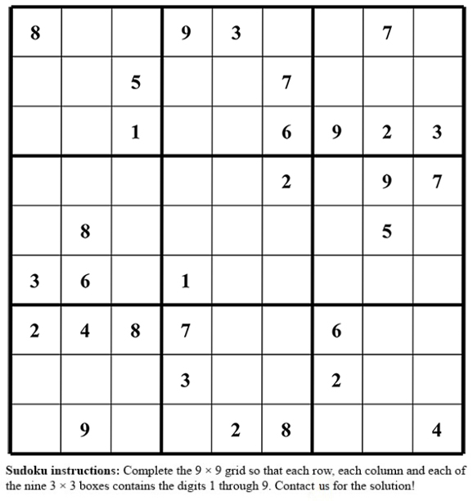

Contact me today:

203-555-8987
sheila@sheilayaccino.com
www.sheilayaccino.com
License # 01209323

